(Approx. 222 words)

Roybi Robot
By George Harding, Treasurer, Tucson Computer Society
www.aztcs.org
actuary110 (at) yahoo.com

This is more than just a child’s toy, although it is designed to be for a child.

In fact, it is an educational companion powered by AI (artificial intelligence).

It tutors young children in languages, with over 500 lessons, 70 categories and a 70,000 word vocabulary in Chinese and English.

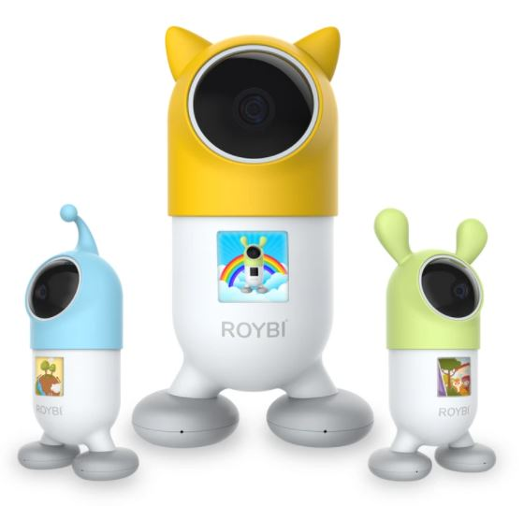

In the company’s words, “Through play, children can learn a second language, practice language arts, explore scientific subjects and develop communication and analytical thinking skills.”

The categories include sessions in technology, math, science and language arts. Here are some of them:
- Alphabet
- Continents
- Places
- Math
- Senses
- Science
- Biology
- Nouns

The categories and content are updated from time to time.

The robot includes voice recognition (understands your child’s responses), has a 1080p camera, has a durable body to withstand drops, is made with material that is safe for children, and has an 8 hour battery.

It is powered by connection to a USB port by the included cable.

Mandarin-Chinese and English are currently supported, but French, Spanish, German, and Russian versions are being planned.

Ages 2-8 are recommended for English use, but for learning a new language, there is no age limit.

An Android app is available for parent use for scheduling or directed learning.

Roybi Robot
https://roybirobot.com/
Price $300, currently $150 (4/3/21)

